**National University of Computer and Emerging Sciences, Lahore Campus**

|  |  |  |  |  |
| --- | --- | --- | --- | --- |
| C:\Users\saif\AppData\Local\Microsoft\Windows\Temporary Internet Files\Content.Word\final design.jpg | **Course Name:** | **Theory of Automata** | **Course Code:** | **CS-3005** |
| **Degree Program:** | **BS (CS)** | **Semester:** | **Spring 2024** |
| **Exam Duration:** | **60 Minutes** | **Total Marks:** | **30** |
| **Paper Date:** | **2-10-2023** | **Weight** | **15%** |
| **Section:** | **ALL** | **Page(s):** | **7** |
| **Exam Type:** | **Midterm-I** |  |  |

## Student : Name: Roll No. Section:

**Instruction/Notes:** Answer in the space provided, showing complete working.

# ROUGH SHEETS ARE NOT ALLOWED.

In case of confusion or ambiguity make a reasonable assumption.

Good luck!

## Question 1: (10 points):

Design deterministic finite automata (DFA) of the following language:

∑ = {0,1}

L= {x | x ∈ ∑* and |x| should be multiple of 3 and every three-length chunk of the string contains at most two occurrences of 0}

***010 and 001100 are two of the accepting strings 0101 and 000010 are two of the rejecting strings***

**School of Computer Science Page 1 of 7**

## Question 2: (5 points):

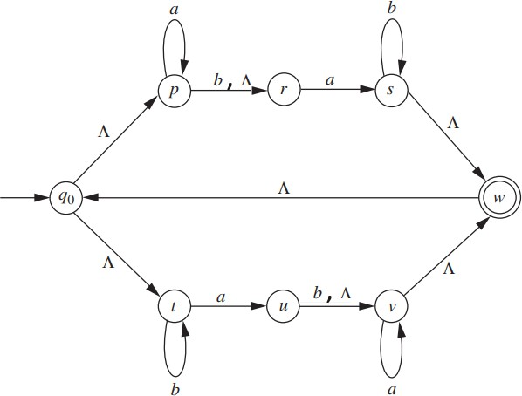Using the extended transition function for NFA-NULL, tell whether the string **ab** ∈ L or not. Show full working.

**Question 3 (5+2 +2+2+4 = 15 points): Short answers**

# PART A

Consider a language L defined over the alphabet set Ʃ. Suppose D1 is a deterministic finite automata (DFA) with 5 tuples (Q,Ʃ, q0, A, T) where

Q = finite set of states

Ʃ = finite set of alphabets q0 = initial state

A= set of final states

T= set of transition functions.

Construct finite automata F1 ((DFA or NFA or NFA-NULL but clearly mention which FA you have developed)) for LR where

LR = Reverse of L.

You have to define all the 5 tuples of F1 (Q1,Ʃ1, p0, A1, T1)

Q1 = { }

Ʃ1 = { }

p0=

A1 = { }

T1= {

}

FA =

## Hint:

**Construct FA for LR and then fill the tuples.**

If L accepts the string x= x0 x1 …. xn { where x0 x1 …. xn ɛ Ʃ ) then LR will accept y= xn xn-1 …. x1 x0.

## For example

Example #1

L= {x| x ɛ {a,b}* and x = abbb}

Then

LR = {x| x ɛ {a,b}* and x= bbba}

Example #2

L= {x| x ɛ {a,b}* and x ends with ab}

Then

LR = {x| x ɛ {a,b}* and x starts with ba}

# PART B

True/ False with justification (no marks without justification)

Every DFA is also a NFA-NULL

# PART C

Language is regular if it has and .

# PART D

Give regular expression for the following language. L= {x| x ɛ{a,b}* and x starts with ab and ends with ba}

Ans:

# PART E

NFA for the Language L is given below.

1. Write regular expression for the language accepted by this FA? [Hint: No need to apply state elimination method]
2. Enumerate the language L’ (complement of L) [at least 10 elements in increasing order of length]

//for rough work